Artists & Speakers
Marwen Art Fair 2025 | Media Preview
Wednesday, October 15, 10 am - noon
Marwen, 833 N. Orleans Street
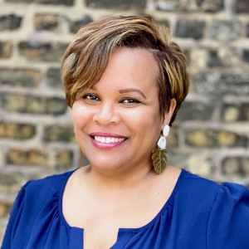
Akilah Halley, Marwen Executive Director & Alumna
ahalley@marwen.org

Akilah Halley (she/her), a Marwen alum, was appointed Executive Director in October 2018. Previously, she served as Marwen’s Deputy Director and a member of the Board of Directors for eight years. Akilah’s experience focuses on human-centered strategies for social change through youth and community development. Her past roles include leading communications and family engagement with Crown Family Philanthropies, marketing with Urban Gateways, and external relations with Chicago Public Schools. She is a member of Chicago’s Cultural Advisory Council and an alum of the Sorkin Center Children Leadership Program and National Arts Strategies Chief Executive Program. Akilah served on Mayor Lightfoot’s Arts and Culture Transition Committee Co-Chair and is a former co-chair of Chicago African Americans in Philanthropy. She holds a graduate degree in design planning from the Institute of Design at Illinois Institute of Technology and a BFA in industrial design from the University of Illinois at Urbana Champaign.

Emma “Stitch Gawd” Mckee, Teaching Artist
@thestitchgawd | https://stitchgawd.com/ | emma@stitchgawd.com

Teaching artist Emma Mckee a.k.a. Stitch Gawd isn’t your average cross stitcher. Born in Kansas City, she was first introduced to the medium through her mother, a British opera singer who frequently attempted to teach Emma how to stitch during her childhood. Yet she always refused to learn, finding the British craft too antiquated — that is, until she found a way to make cross stitching work for her. In 2014, Emma stitched her first piece: An adaptation of Will Prince’s artwork for Chance the Rapper’s song “Hey Ma.” She followed that with a piece for street artist JC Rivera, Chicago’s “Bear Champ.” Her portfolio expanded from there, as she firmly planted herself within Chicago’s rap community, as the scene’s preeminent — and only — hip-hop cross stitcher, earning the name Stitch Gawd. Since 2014, she’s created countless pieces for musicians and artists both in and outside Chicago.
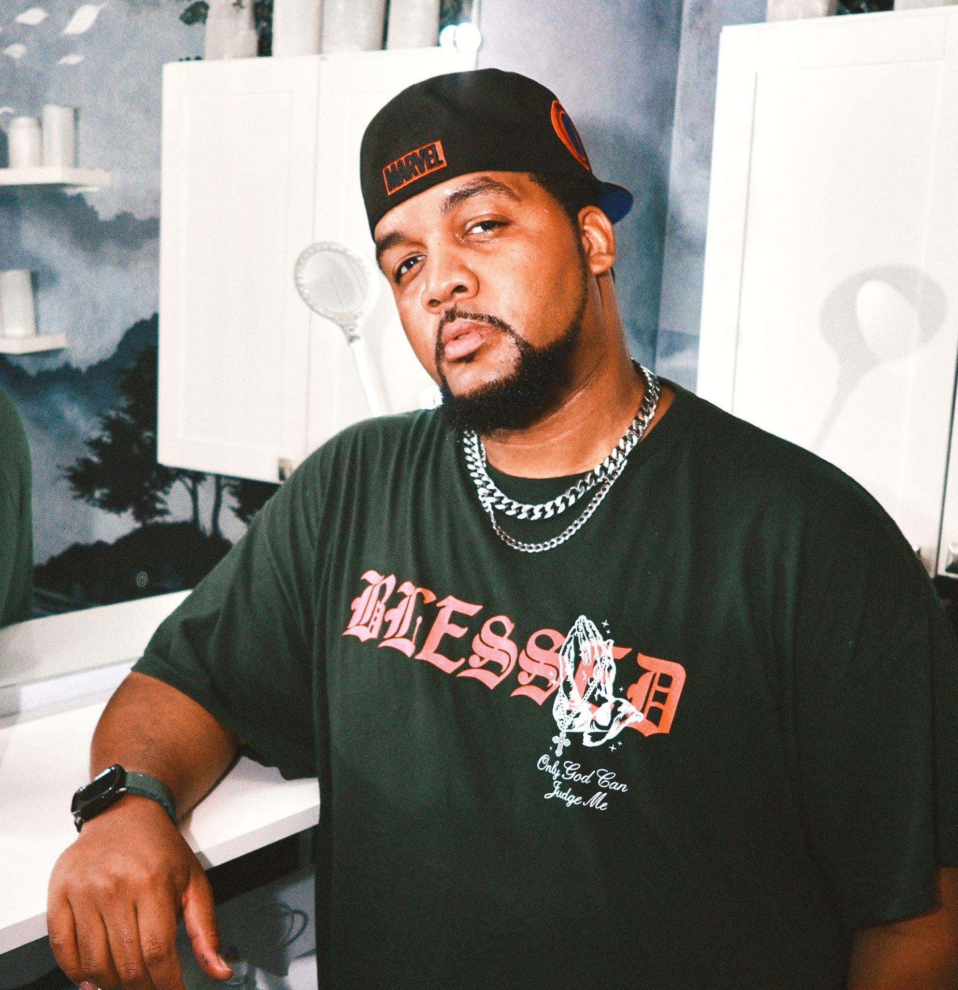
Hamza “IN-ZO” Muhammad, Marwen Alumnus and Artist
inzoshowgraphix@gmail.com | Portfolio | IMDB

Hamza “IN-ZO” Muhammad is a Chicago-based fine artist, designer, and Marwen alumnus whose cross-disciplinary practice bridges fine art, fashion, and film. As the founder of IN-ZO Brand and Head Graphic Designer for the acclaimed television series The Chi, he has helped shape visual worlds for major productions including Showtime’s The Chi (Seasons 6 & 7), ABC’s Will Trent, Heist 88, The Big Leap, and If You Were the Last starring Anthony Mackie.

His creative work has reached more than 30 million viewers worldwide, earning recognition from Rolling Stone, The Hollywood Reporter, Variety, Deadline, and Good Morning America. Beyond the screen, IN-ZO continues to produce immersive hand-painted activations and large-scale installations that merge street-level energy with couture sensibility. Renowned for his inventive, non-classifiable aesthetic, IN-ZO’s murals across Chicago, Houston, and Miami redefine contemporary visual storytelling through a fearless fusion of art, culture, and design.
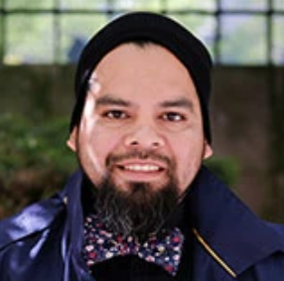
Hector Gonzalez, Marwen Board Member and Artist
hekter23@gmail.com

A Marwen and City Year alum, Hector is a painter who now leads the Career and Technical Pathways Programs for the City Colleges of Chicago and Career Launch Chicago. Hector is an experienced college and career counselor and has also served as a post-secondary advisor for Chicago Public Schools high school students.

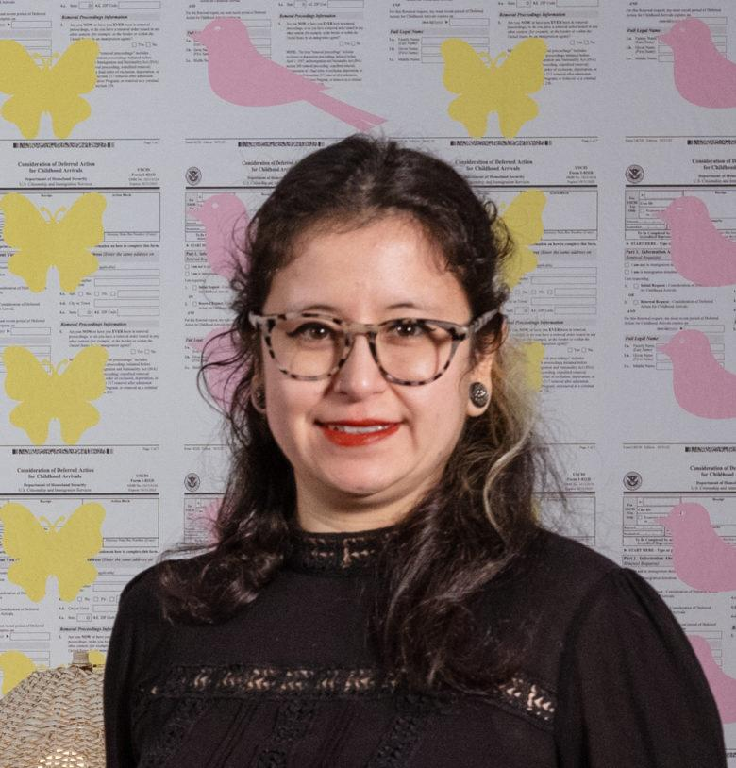
Martha Osornio Ruiz, Senior Manager of Studio Programs
mosornioruiz@marwen.org | Habla Español

Martha Osornio Ruiz (she/her) is a Marwen alumna. She has been involved with Pilsen Neighbors Community Council, Yollocali, and We are Humboldt Park Film Skool. As the Manager of Studio Programs, she understands the importance of having access to free arts programs. Martha is passionate about social justice issues surrounding the immigrant community and has collaborated with Southern Illinois Immigration Rights. She is a member of the Undocumented Filmmakers Collective and Mezcla Media Collective. She is also a huge plant mom and is always available for a coffee trip and walk through the National Museum of Mexican Fine Art.
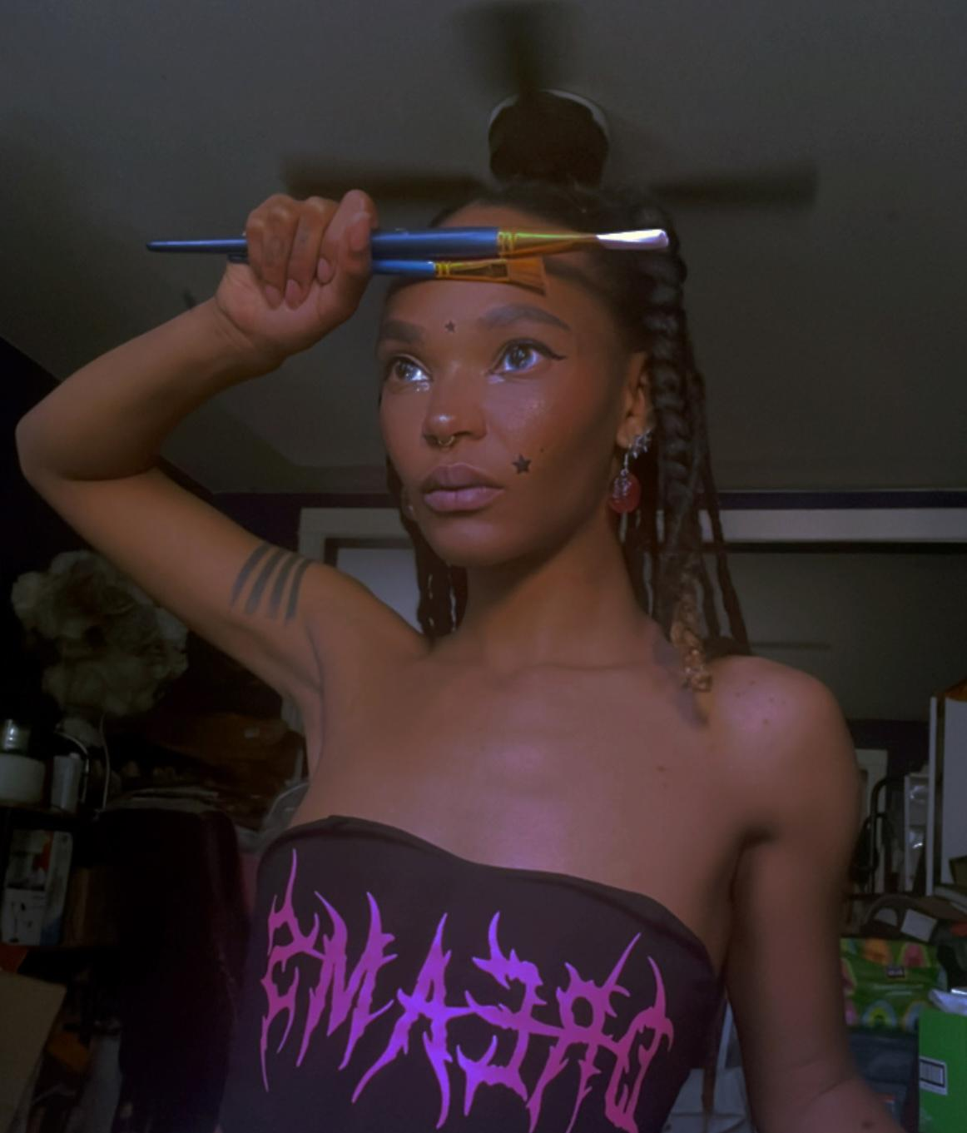
Erica Scott, Teaching Artist & former META
https://artbyscotte.wixsite.com/m00dydreamer | @m00dydreamer | artbyscotte@gmail.com

Erica Scott (she/her) was born and raised on the South Side of Chicago, coming from a community where art was overlooked and under taught. She developed a strong interest in drawing at a young age. Her deep interest in Chicago’s underground punk and goth scenes has always highly influenced her art. She earned a BFA from the School of the Art Institute of Chicago and focused mainly on figurative art. She came to Marwen as a META (Marwen Emerging Teaching Artist). She enjoys drawing and painting people, food, and gore. Recently, Erica has started incorporating retro themes and aesthetics like vapor wave, y2k, and distortion. She draws inspiration from early 2000s social media and the internet era. As an artist, Erica's hope is for the viewer to be transported to a place where life, death, and whimsy intersect.

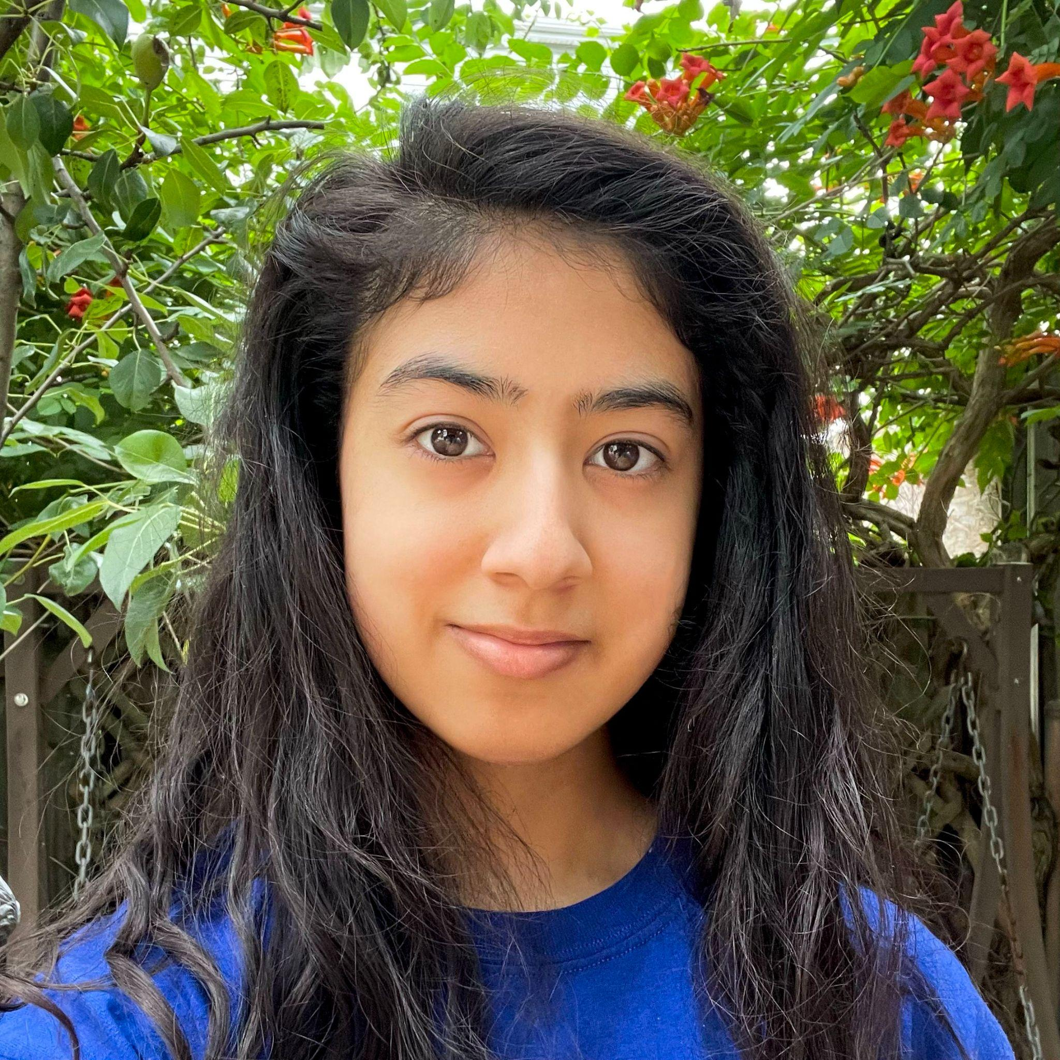
Jackie Reyes, Alumna
@jackie_reyes_art | jackier0903@gmail.com

Jackie Reyes (she/her) is a South Chicago artist and Marwen alum whose work is inspired by flora and fauna. Her work primarily uses recycled materials such as scrap wood and recycled paper to maintain a sustainable art practice. Fish have been her current muse for their variety of colors and diverse silhouettes.

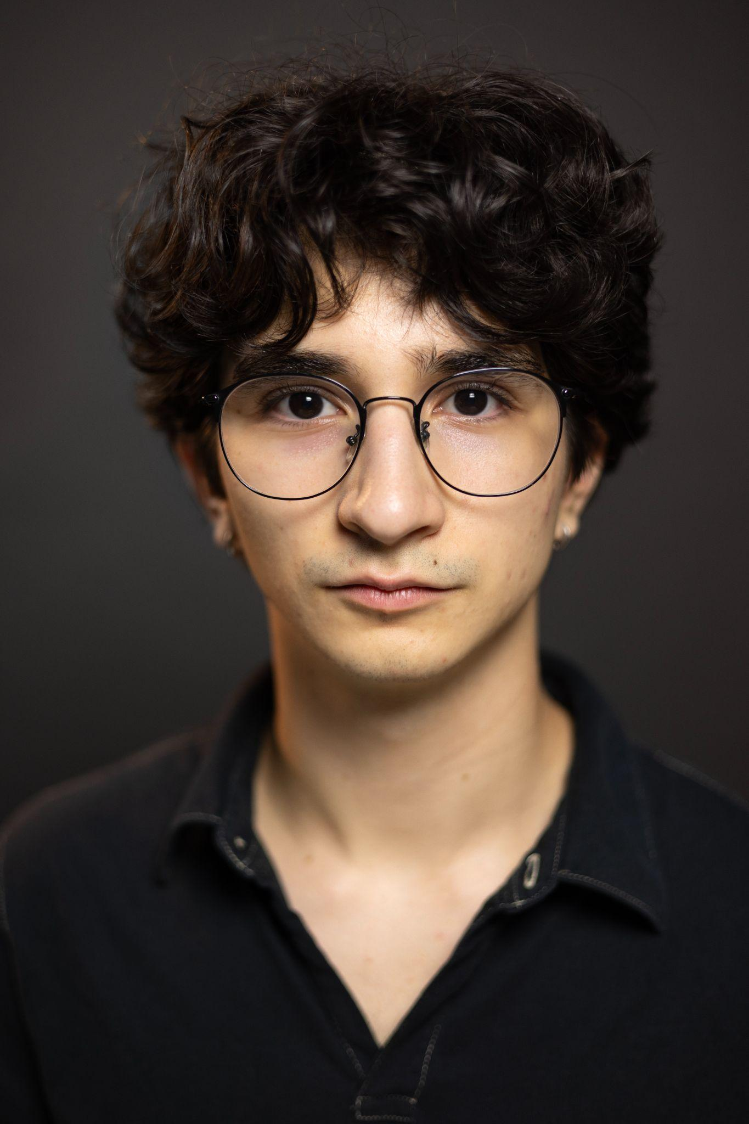
Güneş Göker, Marwen Young Artist
@gunesgoker | gunesgoker.com | totorri33@gmail.com

Gunes Goker is a Turkish-born filmmaker based in Chicago. He is currently completing his senior year at the Chicago Academy for the Arts, where he specializes in directing, cinematography, photography, and editing. Drawing on his background in both Istanbul and Chicago, Gunes brings an international perspective to his storytelling, striving to create films that are both formally rigorous and emotionally resonant. In parallel with his filmmaking, he maintains a professional photography practice. His ongoing “Backstage Photography” series captures candid, emotionally rich moments behind the scenes of various productions. Additionally, his photographic catalog spans documentary street photography, nature, event and people photography, as well as scenes from Turkey.

